**Dr. B.R Ambedkar National Institute of Technology, Jalandhar**



**Introduction to Design and analysis of algorithms Lab**

**(ITPC - 222)**

***Submitted to Submitted By***

Dr. Mohit Kumar Aditya Anand

Department of IT 20124009

IT (G1)

**Table of contents**

|  |  |  |  |  |
| --- | --- | --- | --- | --- |
| Sr.No. | Name of Programs | Date of Implementation | Page No. | Remarks |
| 1. | * 1. Linear Search   2. Binary Search   3. Selection Sort | Jan 06, 2022 |  |  |
| 2. | * 1. Insertion Sort   2. Quick Sort | Jan 31, 2022 |  |  |
| 3. | Merge Sort | Feb 07, 2022 |  |  |
| 4. | * 1. Binary Search using Recursion   2. Factorial using Recursion   3. Fibonacci series using Recursion   4. Sum of n Natural numbers using Recusion | Feb 14, 2022 |  |  |
| 5. | Matrix Multiplication using recursion (Strassen’s method) | Mar 24, 2022 |  |  |
| 6. | Heap Sort | Mar 24, 2022 |  |  |
| 7. | Binomial Heap   * 1. Make Heap   2. Find Min   3. Union   4. Insert a node   5. Extract min   6. Decrease a key   7. Delete a node | Mar 31, 2022 |  |  |
| 8. | Fibonacci Heap   * 1. Make Heap   2. Insert   3. Find Min   4. Extract Min   5. Union   6. Decrease a key   7. Delete | April 7, 2022 |  |  |
| 9. | Red Black Tree   * 1. Inserting an element   2. Deleting an element | April 14, 2022 |  |  |
| 10. | Greedy Algorithms   * 1. Deadline based job scheduling   2. Activity Selection Problem   3. Huffman Code   4. Kruskals Algorithm(MST)   5. Prims Algorithm(MST)   6. Fractional Knapsack   7. Dijkstras Algorithm(SSSP)   8. Bellman Ford | April 21, 2022 |  |  |
| 11. | Dynamic Programming Algorithms  11.1) 0/1 Knapsack  11.2) Assembly Scheduling  11.3) LCS  11.4) MCM  11.5) Bellman Ford  11.6) Floyd Warshall  11.7) Optimal BST | April 28, 2022 |  |  |

**Lab – 1**

|  |  |  |  |
| --- | --- | --- | --- |
| **S No** | **Program Title** | **Date of Implementation** | **Remarks** |
| i. | Linear Search | Jan 6, 2022 |  |
| ii. | Binary Search | Jan 6, 2022 |  |
| iii. | Selection Sort | Jan 6, 2022 |  |

1. **Linear Search**

Input: Array of integer

Output: Index of element to be search in input array

Time Complexity: O(n)

Code:

#include<bits/stdc++.h>

using namespace :: std;

// O(n)

bool seq_search(vector<int> v, int target){

    for(int i=0; i<v.size(); i++){

        if(target==v[i]){

            return true;

        }

    }

    return false;

}

int main(){

    int n = 0;

    cin>>n;

    vector<int> v(n, 0);

    for(int i=0; i<n; i++){

        cin>>v[i];

    }

    int target = 0;

    cin>>target;

    cout<<"SEQUENTIAL SEARCH:\n";

    if(seq_search(v, target)){

        cout<<"Present\n";

    }

    else{

        cout<<"Not Present\n";

    }

    return 0;

}

**Output:**

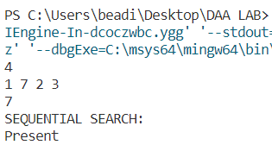

1. **Binary Search**

Input: Array of integer

Output: Index of element to be search in sorted input array

Time Complexity: O(log(n))

Code:

#include<bits/stdc++.h>

using namespace :: std;

// O(log(n))

bool binarySearch(vector<int> v, int target){

    int i=0, j=v.size()-1;

    while(j>=i){

        int mid = i + (j-i)/2;

        if(v[mid]==target){

            return true;

        }

        else if(v[mid]>target){

            j=mid-1;

        }

        else{

            i=mid+1;

        }

    }

    return false;

}

int main(){

    int n = 0;

    cin>>n;

    vector<int> v(n, 0);

    for(int i=0; i<n; i++){

        cin>>v[i];

    }

    int target = 0;

    cin>>target;

    cout<<"BINARY SEARCH:\n";

    if(binarySearch(v, target)){

        cout<<"Present\n";

    }

    else{

        cout<<"Not Present\n";

    }

    return 0;

}

**Output:**

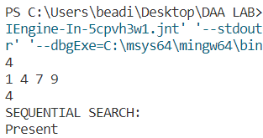

1. **Selection Sort**

Input: Array of integer

Output: Index of element to be search in input array

Time Complexity: O(n^2)

Code:

#include<bits/stdc++.h>

using namespace :: std;

// O(n^2)

void selection_sort(vector<int> &v){

    // Array from 0 to i-1 is sorted, i to n is unsorted

    int i=0;

    while(i<v.size()){

        int mn = INT_MAX;

        int id = -1;

        for(int j=i; j<v.size(); j++){

            if(mn>v[j]){

                mn = v[j];

                id = j;

            }

        }

        swap(v[i], v[id]);

        i++;

        for(auto ele:v){

            cout<<ele<<" ";

        }

        cout<<"\n";

    }

}

int main(){

    int n=0;

    cin>>n;

    vector<int> v(n, 0);

    for(int i=0; i<n; i++){

        cin>>v[i];

    }

    selection_sort(v);

    cout<<"Sorted array: ";

    for(auto i:v){

        cout<<i<<" ";

    }

    return 0;

}

**Output:**

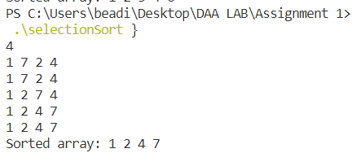

**Lab – 2**

|  |  |  |  |
| --- | --- | --- | --- |
| **S No** | **Program Title** | **Date of Implementation** | **Remarks** |
| i. | Insertion Sort | Jan 31, 2022 |  |
| ii. | Quick sort | Jan 31, 2022 |  |

1. **Insertion Sort**

Input: Array of integer

Output: Sorted array of integer

Time Complexity: O(n^2)

Code:

#include <bits/stdc++.h>

using namespace :: std;

void insertionSort(vector<int> &arr, int n){

    int i, key, j;

    for (i = 1; i < n; i++){

        key = arr[i];

        cout<<"key = "<<key<<"\n";

        j = i - 1;

        while (j >= 0 && arr[j] > key){

            arr[j + 1] = arr[j];

            j--;

        }

        arr[j + 1] = key;

        for(auto i: arr){

            cout<<i<<" ";

        }

        cout<<"\n";

    }

    return;

}

int main(){

    vector<int> arr = {7,8,2,5,6};

    int n = arr.size();

    insertionSort(arr, n);

    cout<<"Sorted Array: ";

    for(auto i:arr){

        cout<<i<<" ";

    }

    return 0;

}

**Output:**

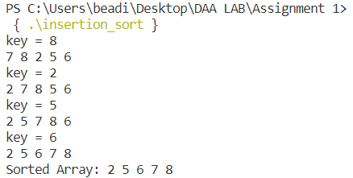

1. **Quick Sort**

Input: Array of integer

Output: Sorted array of integer

Time Complexity:

Best case: Ω(n*log(n)) Average case: θ(n*log(n)) Worst case: O(n^2)

Code:

#include <bits/stdc++.h>

using namespace std;

int N;

void printArray(int arr[], int size)

{

    int i;

    for (i = 0; i < size; i++)

        cout << arr[i] << " ";

    cout << endl;

}

int partition1(int a[], int start, int end)

{

    int pivot = a[start], p1 = start + 1, i, temp;

    for (i = start + 1; i <= end; i++)

    {

        if (a[i] < pivot)

        {

            if (i != p1)

            {

                temp = a[p1];

                a[p1] = a[i];

                a[i] = temp;

            }

            p1++;

        }

    }

    a[start] = a[p1 - 1];

    a[p1 - 1] = pivot;

    return p1 - 1;

}

void quicksort(int *a, int start, int end)

{

    int p1;

    if (start < end)

    {

        p1 = partition1(a, start, end);

        quicksort(a, start, p1 - 1);

        quicksort(a, p1 + 1, end);

    }

}

int main()

{

    int arr[] = {7, 8, 2, 5, 6};

    int n = sizeof(arr) / sizeof(arr[0]);

    N = n;

    quicksort(arr, 0, n - 1);

    cout << "Sorted array: \n";

    printArray(arr, n);

    return 0;

}

**Output:**

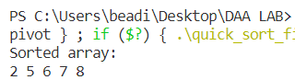

**Lab – 3**

|  |  |  |  |
| --- | --- | --- | --- |
| **S No** | **Program Title** | **Date of Implementation** | **Remarks** |
| i. | Merge Sort | Feb 07, 2022 |  |

**Merge Sort**

Input: Array of integer

Output: Sorted array of integer

Time Complexity: O(n*log(n))

Code:

#include <iostream>

using namespace std;

void merge(int *arr, int low, int mid, int high)

{

    int n1 = mid - low + 1, n2 = high - mid;

    int left[n1], right[n2];

    for (int i = 0; i < n1; i++) // making auxiliary arrays left and right

        left[i] = arr[i + low];

    for (int i = 0; i < n2; i++)

        right[i] = arr[mid + 1 + i];

    int i = 0, j = 0, k = low;

    for (; i < n1 && j < n2;)

    {

        if (left[i] <= right[j])

        {

            arr[k] = left[i];

            i++;

            k++;

        }

        else

        {

            arr[k] = right[j];

            k++;

            j++;

        }

    }

    while (i < n1)

    { // if i<n1 this loop run

        arr[k] = left[i];

        i++, k++;

    }

    while (j < n2)

    { // else if j<n2 this loop run

        arr[k] = right[j];

        k++, j++;

    }

    cout << "Work done by Merge function: ";

    for (int i = low; i <= high; i++)

    {

        cout << arr[i] << " ";

    }

    cout << endl

         << endl;

}

void mergeSort(int *arr, int left, int right)

{

    static int size = right + 1;

    if (left < right)

    {

        int mid = (left + right) / 2;

        mergeSort(arr, left, mid);

        mergeSort(arr, mid + 1, right);

        merge(arr, left, mid, right);

        cout << "Array after internal merge sort working:  ";

        for (int i = 0; i < size; i++)

        {

            cout << arr[i] << " ";

        }

        cout << endl;

    }

}

int main()

{

    cout << "------MERGE SORT------" << endl

         << endl;

    int n = 0;

    cout << "Enter the size of array: ";

    cin >> n;

    int arr[n];

    cout << "Enter the array elements: ";

    for (int i = 0; i < n; i++)

        cin >> arr[i];

    cout << "\nArray before sorting: ";

    for (int i = 0; i < n; i++)

        cout << arr[i] << " ";

    cout << endl

         << endl;

    mergeSort(arr, 0, n - 1);

    cout << "\nArray after sorting: ";

    for (int i = 0; i < n; i++)

        cout << arr[i] << " ";

    return 0;

}

**Output:**

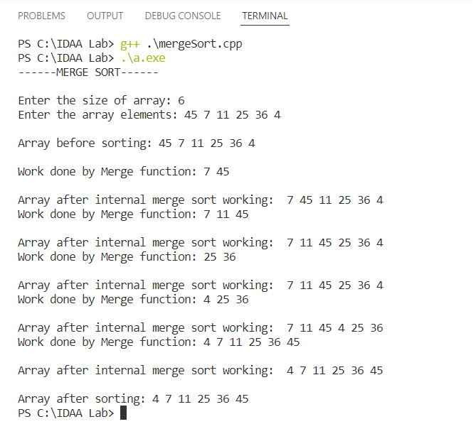

**Lab – 4**

|  |  |  |  |
| --- | --- | --- | --- |
| **S No** | **Program Title** | **Date of Implementation** | **Remarks** |
| i. | Binary Search using Recusion | Feb 14, 2022 |  |
| ii. | Factorial using Recusion | Feb 14, 2022 |  |
| iii. | Fibonacci series using Recursion | Feb 14, 2022 |  |
| iv. | Sum of n Natural numbers using Recusion | Feb 14, 2022 |  |

1. **Binary Search**

Input: Array of integer

Output: Index of element to be search in sorted input array

Time Complexity: O(log(n))

Code:

#include<bits/stdc++.h>

using namespace :: std;

int binarySearch(vector<int> v, int s, int e, int key){

    if(s>e){

        return -1;

    }

    int mid = s+(e-s)/2;

    if(v[mid]==key){

        return mid;

    }

    else if(v[mid]>key){

        return binarySearch(v, s, mid-1, key);

    }

    else{

        return binarySearch(v, mid+1, e, key);

    }

}

int main(){

    vector<int> v = {1,2,3,6,8,9};

    int n = v.size();

    cout<<"Enter key: ";

    int key=0;

    cin>>key;

    int idx = binarySearch(v, 0, n-1, key);

    if(idx!=-1){

        cout<<"Present at index "<<idx;

    }

    else{

        cout<<"Element is not present";

    }

    return 0;

}

**Output:**

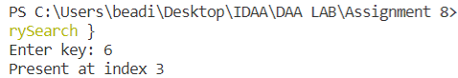

1. **Factorial**

Input: Integer

Output: Factorial of input integer

Time Complexity: O(n)

Code:

#include<bits/stdc++.h>

using namespace :: std;

int factorial(int n){

    if(n==0){

        return 1;

    }

    return n*factorial(n-1);

}

int main(){

    int n=0;

    cin>>n;

    cout<<n<<" factorial ="<<factorial(n)<<"\n";

    return 0;

}

**Output:**

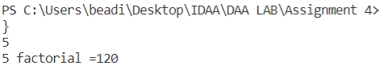

1. **Fibonacci**

Input: Integer

Output: Fibonacci series having length equal to Input integer

Time Complexity: O(n)

Code:

#include<bits/stdc++.h>

using namespace :: std;

int fibonacci(int n){

    if(n==0 || n==1){

        return n;

    }

    return fibonacci(n-1)+fibonacci(n-2);

}

int main(){

    int n = 0;

    cin>>n;

    cout<<n<<"th fibonacci = "<<fibonacci(n);

    return 0;

}

**Output:**

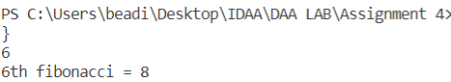

1. **Sum of n Natural numbers**

Input: Integer

Output: Sum from 1 to input integer value

Time Complexity: O(n)

Code:

#include<bits/stdc++.h>

using namespace :: std;

int sum(int n){

    if(n==1){

        return 1;

    }

    return n+sum(n-1);

}

int main(){

    int n=0;

    cin>>n;

    cout<<"sum of first "<<n<< " numbers = "<<sum(n);

    return 0;

}

**Output:**

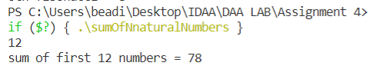

**Lab – 5**

|  |  |  |  |
| --- | --- | --- | --- |
| **S No** | **Program Title** | **Date of Implementation** | **Remarks** |
| i. | Matrix Multiplication using recursion | March 24, 2022 |  |

**Matrix Multiplication**

Input: 2 Matrix of integers

Output: Product of matrices in matrix form

Time Complexity: O(n^2.81)

Code:

#include <bits/stdc++.h>

using namespace std;

int **setAllZero(int n)

{

    int **res = new int *[n];

    for (int i = 0; i < n; i++)

    {

        res[i] = new int[n];

        for (int j = 0; j < n; j++)

        {

            res[i][j] = 0;

        }

    }

    return res;

}

int **matrixAddition(int **arr, int **arr1, int n)

{

    int **res = setAllZero(n);

    for (int i = 0; i < n; i++)

    {

        for (int j = 0; j < n; j++)

        {

            res[i][j] = arr[i][j] + arr1[i][j];

        }

    }

    return res;

}

int **matrixSubtraction(int **arr, int **arr1, int n)

{

    int **res = setAllZero(n);

    for (int i = 0; i < n; i++)

    {

        for (int j = 0; j < n; j++)

        {

            res[i][j] = arr[i][j] - arr1[i][j];

        }

    }

    return res;

}

int **matrixMultiplication(int **arr, int **arr1, int n)

{

    int **res = setAllZero(n);

    if (n == 1)

    {

        res[0][0] = arr[0][0] * arr1[0][0];

        return res;

    }

    int **a11 = setAllZero(n / 2);

    int **a12 = setAllZero(n / 2);

    int **a21 = setAllZero(n / 2);

    int **a22 = setAllZero(n / 2);

    int **b11 = setAllZero(n / 2);

    int **b12 = setAllZero(n / 2);

    int **b21 = setAllZero(n / 2);

    int **b22 = setAllZero(n / 2);

    for (int i = 0; i < n / 2; i++)

    {

        for (int j = 0; j < n / 2; j++)

        {

            a11[i][j] = arr[i][j];

            a12[i][j] = arr[i][n / 2 + j];

            a21[i][j] = arr[i + n / 2][j];

            a22[i][j] = arr[i + n / 2][j + n / 2];

            b11[i][j] = arr1[i][j];

            b12[i][j] = arr1[i][n / 2 + j];

            b21[i][j] = arr1[i + n / 2][j];

            b22[i][j] = arr1[i + n / 2][j + n / 2];

        }

    }

    int **p = matrixMultiplication(matrixAddition(a11, a22, n / 2), matrixAddition(b11, b22, n / 2), n / 2);

    int **q = matrixMultiplication(matrixAddition(a21, a22, n / 2), b11, n / 2);

    int **r = matrixMultiplication(a11, matrixSubtraction(b12, b22, n / 2), n / 2);

    int **s = matrixMultiplication(a22, matrixSubtraction(b21, b11, n / 2), n / 2);

    int **t = matrixMultiplication(matrixAddition(a11, a12, n / 2), b22, n / 2);

    int **u = matrixMultiplication(matrixSubtraction(a21, a11, n / 2), matrixAddition(b11, b12, n / 2), n / 2);

    int **v = matrixMultiplication(matrixSubtraction(a12, a22, n / 2), matrixAddition(b21, b22, n / 2), n / 2);

    int **c11 = matrixAddition(p, matrixAddition(v, matrixSubtraction(s, t, n / 2), n / 2), n / 2);

    int **c12 = matrixAddition(r, t, n / 2);

    int **c21 = matrixAddition(q, s, n / 2);

    int **c22 = matrixAddition(p, matrixAddition(u, matrixSubtraction(r, q, n / 2), n / 2), n / 2);

    for (int i = 0; i < n / 2; i++)

    {

        for (int j = 0; j < n / 2; j++)

        {

            res[i][j] = c11[i][j];

            res[i][j + n / 2] = c12[i][j];

            res[i + n / 2][j] = c21[i][j];

            res[i + n / 2][j + n / 2] = c22[i][j];

        }

    }

    return res;

}

int main()

{

    int n;

    cout << "Enter the dimension : ";

    cin >> n;

    int **arr = setAllZero(n);

    int **arr1 = setAllZero(n);

    cout << "Enter the elements for first matrix : " << endl;

    for (int i = 0; i < n; i++)

    {

        for (int j = 0; j < n; j++)

        {

            cin >> arr[i][j];

        }

    }

    cout << "Enter the elements for second matrix : " << endl;

    for (int i = 0; i < n; i++)

    {

        for (int j = 0; j < n; j++)

        {

            cin >> arr1[i][j];

        }

    }

    int **res;

    res = matrixMultiplication(arr, arr1, n);

    cout << "The multiplication of 2 matrices is : " << endl;

    for (int i = 0; i < n; i++)

    {

        for (int j = 0; j < n; j++)

        {

            cout << res[i][j] << "\t";

        }

        cout << endl;

    }

}

**Output:**

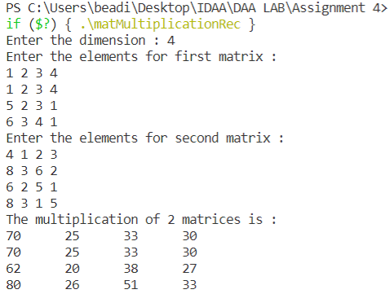

**Lab – 6**

|  |  |  |  |
| --- | --- | --- | --- |
| **S No** | **Program Title** | **Date of Implementation** | **Remarks** |
| i. | Heap Sort | Mar 23, 2022 |  |

**Heap Sort**

Input: Array of integer

Output: Sorted array of integer

Time Complexity: O(n*log(n))

Code:

#include<bits/stdc++.h>

using namespace :: std;

void heapSort(vector<int> &v){

    int n=v.size();

    // Create the heap

    for(int i=1; i<n; i++){

        int t=i;

        while((t/2)>0 && v[t/2]>v[t]){

            swap(v[t/2], v[t]);

            t/=2;

        }

    }

    // Remove root from the heap and store it at the end

    for(int i=n-1; i>1; i--){

        swap(v[i], v[1]);

        int t=1;

        while((2*t+1)<i){

            int l=2*t;

            int r=2*t+1;

            if(l<i && r<i){

                if(v[l]<v[r]){

                   if(v[2*t]<v[t]){

                        swap(v[2*t], v[t]);

                        t=2*t;

                        continue;

                    }

                }

                else{

                    if(v[2*t+1]<v[t]){

                        swap(v[2*t+1], v[t]);

                        t=2*t+1;

                        continue;

                    }

                }

            }

            else{

                break;

            }

        }

        if((2*t+1)==i){

            if(v[2*t]<v[t]){

                swap(v[2*t], v[t]);

                t=2*t;

            }

        }

    }

}

int main(){

    int n=0;

    cin>>n;

    vector<int> v(n+1, 0);   // because 1 based indexing

    for(int i=1; i<n+1; i++){

        cin>>v[i];

    }

    heapSort(v);

    for(int i=1; i<n+1; i++){

        cout<<v[i]<<" ";

    }

    return 0;

}

**Output:**

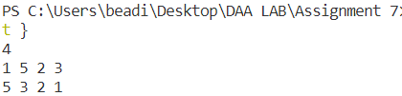

**Lab – 7**

**Binomial Heap**

|  |  |  |  |
| --- | --- | --- | --- |
| **S No** | **Program Title** | **Date of Implementation** | **Remarks** |
| i. | Binomial Heap | Mar 30, 2022 |  |

Input: Integers

Output: Minimum element in heap and full heap traversal print

Time Complexity:

1. Make Heap = O(1)
2. Find Min = O(nlog(n))
3. Union = O(nlog(n))
4. Insert a node = O(nlog(n))
5. Extract min = O(nlog(n))
6. Decrease a key = O(nlog(n))
7. Delete a node = O(nlog(n))

Code:

#include <bits/stdc++.h>

using namespace std;

// A binomial heap node structure

struct node{

    int degree, data;

    struct node *parent, *sibling, *child;

};

// This function creates a new node with given key

struct node *newNode(int key){

    struct node *temp = new node;

    temp->data = key;

    temp->degree = 0;

    temp->child = temp->parent = temp->sibling = NULL;

    return temp;

    }

    // Merging two binomial trees

    struct node *mergeBinomialTrees(struct node *b1, struct node *b2){

    if (b1->data > b2->data)

        swap(b1, b2);

    b2->parent = b1;

    b2->sibling = b1->child;

    b1->child = b2;

    b1->degree++;

    return b1;

    }

    // This function performs union of two Binomial heaps

    list<node *> unionBinomialHeap(list<node *> l1, list<node *> l2){

    list<node *> res;

    auto i = l1.begin();

    auto j = l2.begin();

    while (i != l1.end() && j != l2.end())

    {

        if ((*i)->degree <= (*j)->degree)

        {

        res.push_back((*i));

        i++;

        }

        else

        {

        res.push_back((*j));

        j++;

        }

    }

    while (i != l1.end())

    {

        res.push_back((*i));

        i++;

    }

    while (j != l2.end())

    {

        res.push_back((*j));

        j++;

    }

    return res;

}

// Adjust function ensures that the root nodes in list are in increasing order and no two binomial trees

// have the same degree.

list<node *> adjust(list<node *> heap){

    if (heap.size() <= 1)

        return heap;

    list<node *> new_heap;

    list<node *>::iterator it1, it2, it3;

    it1 = it2 = it3 = heap.begin();

    if (heap.size() == 2)

    {

        it2 = it1;

        it2++;

        it3 = heap.end();

    }

    else

    {

        it2++;

        it3 = it2;

        it3++;

    }

    while (it1 != heap.end())

    {

        if (it2 == heap.end())

        it1++;

        else if ((*it1)->degree < (*it2)->degree)

        {

        it1++;

        it2++;

        if (it3 != heap.end())

            it3++;

        }

        else if (it3 != heap.end() && (*it1)->degree == (*it2)->degree && (*it1)->degree == (*it3)->degree)

        {

        it1++;

        it2++;

        it3++;

        }

        else if ((*it1)->degree == (*it2)->degree)

        {

        struct node *temp;

        *it1 = mergeBinomialTrees(*it1, *it2);

        it2 = heap.erase(it2);

        if (it3 != heap.end())

            it3++;

        }

    }

    return heap;

}

// This function adds a Binomial tree in heap and then performs union on it

list<node *> insertTreeInHeap(list<node *> heap, struct node *tree){

    list<node *> temp;

    temp.push_back(tree);

    temp = unionBinomialHeap(temp, heap);

    return adjust(temp);

}

// This function inserts a new node in Binomial heap

list<node *> insert(int key, list<node *> heap){

    struct node *temp;

    temp = newNode(key);

    return insertTreeInHeap(heap, temp);

}

// This function returns the pointer to the minimum element of entire heap

struct node *getMin(list<node *> heap){

    struct node *minimum = NULL;

    int mini = INT_MAX;

    auto it = heap.begin();

    while (it != heap.end())

    {

        if ((*it)->data < mini)

        {

        mini = (*it)->data;

        minimum = (*it);

        }

        it++;

    }

    return minimum;

}

// This function is a helper function and it includes all the children of minimum node in the main root list and then performs union and adjust to ensure binomial trees of unique degree

list<node *> removeMinimum(struct node *tree){

    list<node *> heap;

    struct node *temp = tree->child;

    struct node *helper;

    while (temp)

    {

        helper = temp;

        temp = temp->sibling;

        helper->sibling = NULL;

        helper->parent = NULL;

        heap.push_front(helper);

    }

    return heap;

}

// This function extracts the minimum node from the Binomial heap and returns the modified heap

list<node *> extractMin(list<node *> heap){

    list<node *> new_heap, helper;

    struct node *temp;

    temp = getMin(heap);

    auto it = heap.begin();

    while (it != heap.end())

    {

        if ((*it) != temp)

        {

        new_heap.push_back((*it));

        }

        it++;

    }

    helper = removeMinimum(temp);

    helper = unionBinomialHeap(new_heap, helper);

    helper = adjust(helper);

    return helper;

}

// This function searches a given Binomial tree for a node with a given value and returns the pointer to that node

struct node *findNode(struct node *h, int val){

  if (h == NULL)

    return NULL;

  if (h->data == val)

    return h;

  struct node *res = findNode(h->child, val);

  if (res != NULL)

    return res;

  return findNode(h->sibling, val);

}

// This function takes input an old and a new key and replaces old key with new key and performs necessary swapping to ensure min-heap property

list<node *> decreaseKey(list<node *> heap, int old_val, int new_val){

  struct node *temp = NULL;

  auto it = heap.begin();

  while (it != heap.end())

  {

    temp = findNode(*it, old_val);

    if (temp != NULL)

      break;

    // (*it) = (*it)->sibling;

    it++;

  }

  if (temp == NULL)

    return heap;

  temp->data = new_val;

  struct node *parent = temp->parent;

  while (parent != NULL && temp->data < parent->data)

  {

    swap(temp->data, parent->data);

    temp = parent;

    parent = parent->parent;

  }

  return heap;

}

// This function takes input a value and deletes the node with corresponding value from the Binary heap

list<node *> deleteNode(list<node *> heap, int val){

  struct node *temp = NULL;

  auto it = heap.begin();

  while (it != heap.end())

  {

    temp = findNode(*it, val);

    if (temp != NULL)

      break;

    it++;

  }

  if (temp == NULL)

  {

    cout << "Value to be deleted not found in heap " << endl;

    return heap;

  }

  temp->data = INT_MIN;

  struct node *parent = temp->parent;

  while (parent != NULL && temp->data < parent->data)

  {

    swap(temp->data, parent->data);

    temp = parent;

    parent = parent->parent;

  }

  heap = extractMin(heap);

  return heap;

}

// This function take input a root of a Binomial tree and prints all the values in that tree using DFS approach

void printTree(struct node *root){

  while (root)

  {

    cout << root->data << " ";

    printTree(root->child);

    root = root->sibling;

  }

}

// This function takes input of a Binomial heap and prints all its key values

void printHeap(list<node *> heap){

  auto it = heap.begin();

  while (it != heap.end())

  {

    printTree(*it);

    it++;

  }

  cout << endl;

}

// Main function

int main(){

    // 1. Creating a Binomial heap

    list<node *> heap;

    // 2. Inserting values in Binomial heap

    heap = insert(1, heap);

    heap = insert(2, heap);

    heap = insert(3, heap);

    heap = insert(4, heap);

    heap = insert(5, heap);

    heap = insert(6, heap);

    cout << "The heap formed is as follows\n";

    printHeap(heap);

    // 3. Getting minimum element from heap

    cout << "The minimum element in heap is " << getMin(heap)->data << endl;

    // 4. Removing minimum element from heap

    heap = extractMin(heap);

    cout << "Heap after extracing minimum value is as follows \n";

    printHeap(heap);

    // 5. Decreasing a key

    heap = decreaseKey(heap, 2, -1);

    cout << "Heap after decreasing a key is as follows\n";

    printHeap(heap);

    // 6. Deleting a node

    heap = deleteNode(heap, 4);

    cout << "Heap after deleting node is as follows\n";

    printHeap(heap);

    return 0;

}

**Output:**

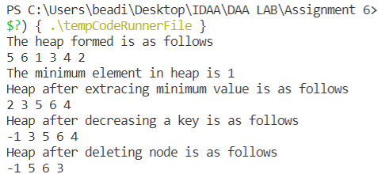

**Lab – 8**

**Binomial Heap**

|  |  |  |  |
| --- | --- | --- | --- |
| **S No** | **Program Title** | **Date of Implementation** | **Remarks** |
| i. | Fibonacci Heap | April 7, 2022 |  |

Input: Integers

Output: Minimum element in heap and full heap traversal print

1. Make Heap = O(1)
2. Find Min = O(1)
3. Union = O(1)
4. Insert a node = O(1)
5. Extract min = O(log(n))
6. Decrease a key = O(1)
7. Delete a node = O(nlog(n))

Time Complexity:

Code:

// C++ program to demonstrate various operations of fibonacci heap

#include<bits/stdc++.h>

using namespace std;

// Creating a structure to represent a node in the heap

struct node {

    node* parent; // Parent pointer

    node* child; // Child pointer

    node* left; // Pointer to the node on the left

    node* right; // Pointer to the node on the right

    int key; // Value of the node

    int degree; // Degree of the node

    char mark; // Black or white mark of the node

    char c; // Flag for assisting in the Find node function

};

// Creating min pointer as "mini"

struct node* mini = NULL;

// Declare an integer for number of nodes in the heap

int no_of_nodes = 0;

// Function to insert a node in heap

void insertion(int val)

{

    struct node* new_node = new node();

    new_node->key = val;

    new_node->degree = 0;

    new_node->mark = 'W';

    new_node->c = 'N';

    new_node->parent = NULL;

    new_node->child = NULL;

    new_node->left = new_node;

    new_node->right = new_node;

    if (mini != NULL) {

        (mini->left)->right = new_node;

        new_node->right = mini;

        new_node->left = mini->left;

        mini->left = new_node;

        if (new_node->key < mini->key)

            mini = new_node;

    }

    else {

        mini = new_node;

    }

    no_of_nodes++;

}

// Linking the heap nodes in parent child relationship

void Fibonnaci_link(struct node* ptr2, struct node* ptr1)

{

    (ptr2->left)->right = ptr2->right;

    (ptr2->right)->left = ptr2->left;

    if (ptr1->right == ptr1)

        mini = ptr1;

    ptr2->left = ptr2;

    ptr2->right = ptr2;

    ptr2->parent = ptr1;

    if (ptr1->child == NULL)

        ptr1->child = ptr2;

    ptr2->right = ptr1->child;

    ptr2->left = (ptr1->child)->left;

    ((ptr1->child)->left)->right = ptr2;

    (ptr1->child)->left = ptr2;

    if (ptr2->key < (ptr1->child)->key)

        ptr1->child = ptr2;

    ptr1->degree++;

}

// Consolidating the heap

void Consolidate()

{

    int temp1;

    float temp2 = (log(no_of_nodes)) / (log(2));

    int temp3 = temp2;

    struct node* arr[temp3+1];

    for (int i = 0; i <= temp3; i++)

        arr[i] = NULL;

    node* ptr1 = mini;

    node* ptr2;

    node* ptr3;

    node* ptr4 = ptr1;

    do {

        ptr4 = ptr4->right;

        temp1 = ptr1->degree;

        while (arr[temp1] != NULL) {

            ptr2 = arr[temp1];

            if (ptr1->key > ptr2->key) {

                ptr3 = ptr1;

                ptr1 = ptr2;

                ptr2 = ptr3;

            }

            if (ptr2 == mini)

                mini = ptr1;

            Fibonnaci_link(ptr2, ptr1);

            if (ptr1->right == ptr1)

                mini = ptr1;

            arr[temp1] = NULL;

            temp1++;

        }

        arr[temp1] = ptr1;

        ptr1 = ptr1->right;

    } while (ptr1 != mini);

    mini = NULL;

    for (int j = 0; j <= temp3; j++) {

        if (arr[j] != NULL) {

            arr[j]->left = arr[j];

            arr[j]->right = arr[j];

            if (mini != NULL) {

                (mini->left)->right = arr[j];

                arr[j]->right = mini;

                arr[j]->left = mini->left;

                mini->left = arr[j];

                if (arr[j]->key < mini->key)

                    mini = arr[j];

            }

            else {

                mini = arr[j];

            }

            if (mini == NULL)

                mini = arr[j];

            else if (arr[j]->key < mini->key)

                mini = arr[j];

        }

    }

}

// Function to extract minimum node in the heap

void Extract_min()

{

    if (mini == NULL)

        cout << "The heap is empty" << endl;

    else {

        node* temp = mini;

        node* pntr;

        pntr = temp;

        node* x = NULL;

        if (temp->child != NULL) {

            x = temp->child;

            do {

                pntr = x->right;

                (mini->left)->right = x;

                x->right = mini;

                x->left = mini->left;

                mini->left = x;

                if (x->key < mini->key)

                    mini = x;

                x->parent = NULL;

                x = pntr;

            } while (pntr != temp->child);

        }

        (temp->left)->right = temp->right;

        (temp->right)->left = temp->left;

        mini = temp->right;

        if (temp == temp->right && temp->child == NULL)

            mini = NULL;

        else {

            mini = temp->right;

            Consolidate();

        }

        no_of_nodes--;

    }

}

// Cutting a node in the heap to be placed in the root list

void Cut(struct node* found, struct node* temp)

{

    if (found == found->right)

        temp->child = NULL;

    (found->left)->right = found->right;

    (found->right)->left = found->left;

    if (found == temp->child)

        temp->child = found->right;

    temp->degree = temp->degree - 1;

    found->right = found;

    found->left = found;

    (mini->left)->right = found;

    found->right = mini;

    found->left = mini->left;

    mini->left = found;

    found->parent = NULL;

    found->mark = 'B';

}

// Recursive cascade cutting function

void Cascase_cut(struct node* temp)

{

    node* ptr5 = temp->parent;

    if (ptr5 != NULL) {

        if (temp->mark == 'W') {

            temp->mark = 'B';

        }

        else {

            Cut(temp, ptr5);

            Cascase_cut(ptr5);

        }

    }

}

// Function to decrease the value of a node in the heap

void Decrease_key(struct node* found, int val)

{

    if (mini == NULL)

        cout << "The Heap is Empty" << endl;

    if (found == NULL)

        cout << "Node not found in the Heap" << endl;

    found->key = val;

    struct node* temp = found->parent;

    if (temp != NULL && found->key < temp->key) {

        Cut(found, temp);

        Cascase_cut(temp);

    }

    if (found->key < mini->key)

        mini = found;

}

// Function to find the given node

void Find(struct node* mini, int old_val, int val)

{

    struct node* found = NULL;

    node* temp5 = mini;

    temp5->c = 'Y';

    node* found_ptr = NULL;

    if (temp5->key == old_val) {

        found_ptr = temp5;

        temp5->c = 'N';

        found = found_ptr;

        Decrease_key(found, val);

    }

    if (found_ptr == NULL) {

        if (temp5->child != NULL)

            Find(temp5->child, old_val, val);

        if ((temp5->right)->c != 'Y')

            Find(temp5->right, old_val, val);

    }

    temp5->c = 'N';

    found = found_ptr;

}

// Deleting a node from the heap

void Deletion(int val)

{

    if (mini == NULL)

        cout << "The heap is empty" << endl;

    else {

        // Decreasing the value of the node to 0

        Find(mini, val, 0);

        // Calling Extract_min function to

        // delete minimum value node, which is 0

        Extract_min();

        cout << "Key Deleted" << endl;

    }

}

// Function to display the heap

void display()

{

    node* ptr = mini;

    if (ptr == NULL)

        cout << "The Heap is Empty" << endl;

    else {

        cout << "The root nodes of Heap are: " << endl;

        do {

            cout << ptr->key;

            ptr = ptr->right;

            if (ptr != mini) {

                cout << "-->";

            }

        } while (ptr != mini && ptr->right != NULL);

        cout << endl

            << "The heap has " << no_of_nodes << " nodes" << endl

            << endl;

    }

}

// Driver code

int main()

{

    // We will create a heap and insert 3 nodes into it

    cout << "Creating an initial heap" << endl;

    insertion(5);

    insertion(2);

    insertion(8);

    // Now we will display the root list of the heap

    display();

    // Now we will extract the minimum value node from the heap

    cout << "Extracting min" << endl;

    Extract_min();

    display();

    // Now we will decrease the value of node '8' to '7'

    cout << "Decrease value of 8 to 7" << endl;

    Find(mini, 8, 7);

    display();

    // Now we will delete the node '7'

    cout << "Delete the node 7" << endl;

    Deletion(7);

    display();

    return 0;

}

**Output:**

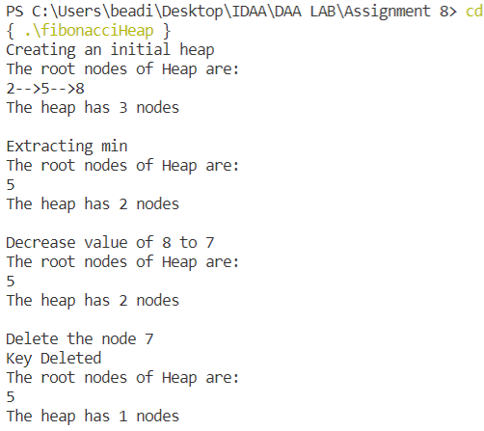

**Lab – 9**

|  |  |  |  |
| --- | --- | --- | --- |
| **S No** | **Program Title** | **Date of Implementation** | **Remarks** |
| i. | Red Black Trees | April 14, 2022 |  |

**Heap Sort**

Input: Array of integer

Output: Sorted array of integer

Time Complexity:

Insert an element

O(log(n))

Delete an element

O(log(n))

Code:

// Implementing Red-Black Tree in C++

#include <iostream>

using namespace std;

struct Node{

    int data;

    Node *parent;

    Node *left;

    Node *right;

    int color;

};

typedef Node *NodePtr;

class RedBlackTree{

private:

    NodePtr root;

    NodePtr TNULL;

    void initializeNULLNode(NodePtr node, NodePtr parent){

        node->data = 0;

        node->parent = parent;

        node->left = nullptr;

        node->right = nullptr;

        node->color = 0;

    }

    // Preorder

    void preOrderHelper(NodePtr node){

        if (node != TNULL){

            cout << node->data << " ";

            preOrderHelper(node->left);

            preOrderHelper(node->right);

        }

    }

    // Inorder

    void inOrderHelper(NodePtr node){

        if (node != TNULL){

            inOrderHelper(node->left);

            cout << node->data << " ";

            inOrderHelper(node->right);

        }

    }

    // Post order

    void postOrderHelper(NodePtr node){

        if (node != TNULL){

            postOrderHelper(node->left);

            postOrderHelper(node->right);

            cout << node->data << " ";

        }

    }

    NodePtr searchTreeHelper(NodePtr node, int key){

        if (node == TNULL || key == node->data){

            return node;

        }

        if (key < node->data){

            return searchTreeHelper(node->left, key);

        }

        return searchTreeHelper(node->right, key);

    }

    // For balancing the tree after deletion

    void deleteFix(NodePtr x){

        NodePtr s;

        while (x != root && x->color == 0){

            if (x == x->parent->left){

                s = x->parent->right;

                if (s->color == 1){

                    s->color = 0;

                    x->parent->color = 1;

                    leftRotate(x->parent);

                    s = x->parent->right;

                }

                if (s->left->color == 0 && s->right->color == 0){

                    s->color = 1;

                    x = x->parent;

                }

                else{

                    if (s->right->color == 0){

                        s->left->color = 0;

                        s->color = 1;

                        rightRotate(s);

                        s = x->parent->right;

                    }

                    s->color = x->parent->color;

                    x->parent->color = 0;

                    s->right->color = 0;

                    leftRotate(x->parent);

                    x = root;

                }

            }

            else

            {

                s = x->parent->left;

                if (s->color == 1){

                    s->color = 0;

                    x->parent->color = 1;

                    rightRotate(x->parent);

                    s = x->parent->left;

                }

                if (s->right->color == 0 && s->right->color == 0){

                    s->color = 1;

                    x = x->parent;

                }

                else{

                    if (s->left->color == 0){

                        s->right->color = 0;

                        s->color = 1;

                        leftRotate(s);

                        s = x->parent->left;

                    }

                    s->color = x->parent->color;

                    x->parent->color = 0;

                    s->left->color = 0;

                    rightRotate(x->parent);

                    x = root;

                }

            }

        }

        x->color = 0;

    }

    void rbTransplant(NodePtr u, NodePtr v){

        if (u->parent == nullptr){

            root = v;

        }

        else if (u == u->parent->left){

            u->parent->left = v;

        }

        else{

            u->parent->right = v;

        }

        v->parent = u->parent;

    }

    void deleteNodeHelper(NodePtr node, int key){

        NodePtr z = TNULL;

        NodePtr x, y;

        while (node != TNULL){

            if (node->data == key){

                z = node;

            }

            if (node->data <= key){

                node = node->right;

            }

            else{

                node = node->left;

            }

        }

        if (z == TNULL){

            cout << "Key not found in the tree" << endl;

            return;

        }

        y = z;

        int y_original_color = y->color;

        if (z->left == TNULL){

            x = z->right;

            rbTransplant(z, z->right);

        }

        else if (z->right == TNULL){

            x = z->left;

            rbTransplant(z, z->left);

        }

        else{

            y = minimum(z->right);

            y_original_color = y->color;

            x = y->right;

            if (y->parent == z){

                x->parent = y;

            }

            else{

                rbTransplant(y, y->right);

                y->right = z->right;

                y->right->parent = y;

            }

            rbTransplant(z, y);

            y->left = z->left;

            y->left->parent = y;

            y->color = z->color;

        }

        delete z;

        if (y_original_color == 0){

            deleteFix(x);

        }

    }

    // For balancing the tree after insertion

    void insertFix(NodePtr k){

        NodePtr u;

        while (k->parent->color == 1){

            if (k->parent == k->parent->parent->right){

                u = k->parent->parent->left;

                if (u->color == 1){

                    u->color = 0;

                    k->parent->color = 0;

                    k->parent->parent->color = 1;

                    k = k->parent->parent;

                }

                else{

                    if (k == k->parent->left){

                        k = k->parent;

                        rightRotate(k);

                    }

                    k->parent->color = 0;

                    k->parent->parent->color = 1;

                    leftRotate(k->parent->parent);

                }

            }

            else{

                u = k->parent->parent->right;

                if (u->color == 1){

                    u->color = 0;

                    k->parent->color = 0;

                    k->parent->parent->color = 1;

                    k = k->parent->parent;

                }

                else{

                    if (k == k->parent->right)

                    {

                        k = k->parent;

                        leftRotate(k);

                    }

                    k->parent->color = 0;

                    k->parent->parent->color = 1;

                    rightRotate(k->parent->parent);

                }

            }

            if (k == root){

                break;

            }

        }

        root->color = 0;

    }

    void printHelper(NodePtr root, string indent, bool last){

        if (root != TNULL){

            cout << indent;

            if (last){

                cout << "R----";

                indent += "   ";

            }

            else{

                cout << "L----";

                indent += "|  ";

            }

            string sColor = root->color ? "RED" : "BLACK";

            cout << root->data << "(" << sColor << ")" << endl;

            printHelper(root->left, indent, false);

            printHelper(root->right, indent, true);

        }

    }

public:

    RedBlackTree(){

        TNULL = new Node;

        TNULL->color = 0;

        TNULL->left = nullptr;

        TNULL->right = nullptr;

        root = TNULL;

    }

    void preorder(){

        preOrderHelper(this->root);

    }

    void inorder(){

        inOrderHelper(this->root);

    }

    void postorder(){

        postOrderHelper(this->root);

    }

    NodePtr searchTree(int k){

        return searchTreeHelper(this->root, k);

    }

    NodePtr minimum(NodePtr node){

        while (node->left != TNULL)

        {

            node = node->left;

        }

        return node;

    }

    NodePtr maximum(NodePtr node){

        while (node->right != TNULL)

        {

            node = node->right;

        }

        return node;

    }

    NodePtr successor(NodePtr x){

        if (x->right != TNULL){

            return minimum(x->right);

        }

        NodePtr y = x->parent;

        while (y != TNULL && x == y->right){

            x = y;

            y = y->parent;

        }

        return y;

    }

    NodePtr predecessor(NodePtr x){

        if (x->left != TNULL){

            return maximum(x->left);

        }

        NodePtr y = x->parent;

        while (y != TNULL && x == y->left){

            x = y;

            y = y->parent;

        }

        return y;

    }

    void leftRotate(NodePtr x){

        NodePtr y = x->right;

        x->right = y->left;

        if (y->left != TNULL){

            y->left->parent = x;

        }

        y->parent = x->parent;

        if (x->parent == nullptr){

            this->root = y;

        }

        else if (x == x->parent->left){

            x->parent->left = y;

        }

        else{

            x->parent->right = y;

        }

        y->left = x;

        x->parent = y;

    }

    void rightRotate(NodePtr x){

        NodePtr y = x->left;

        x->left = y->right;

        if (y->right != TNULL){

            y->right->parent = x;

        }

        y->parent = x->parent;

        if (x->parent == nullptr){

            this->root = y;

        }

        else if (x == x->parent->right){

            x->parent->right = y;

        }

        else{

            x->parent->left = y;

        }

        y->right = x;

        x->parent = y;

    }

    // Inserting a node

    void insert(int key){

        NodePtr node = new Node;

        node->parent = nullptr;

        node->data = key;

        node->left = TNULL;

        node->right = TNULL;

        node->color = 1;

        NodePtr y = nullptr;

        NodePtr x = this->root;

        while (x != TNULL){

            y = x;

            if (node->data < x->data){

                x = x->left;

            }

            else{

                x = x->right;

            }

        }

        node->parent = y;

        if (y == nullptr){

            root = node;

        }

        else if (node->data < y->data){

            y->left = node;

        }

        else{

            y->right = node;

        }

        if (node->parent == nullptr){

            node->color = 0;

            return;

        }

        if (node->parent->parent == nullptr){

            return;

        }

        insertFix(node);

    }

    NodePtr getRoot(){

        return this->root;

    }

    void deleteNode(int data){

        deleteNodeHelper(this->root, data);

    }

    void printTree(){

        if (root){

            printHelper(this->root, "", true);

        }

    }

};

int main(){

    RedBlackTree bst;

    bst.insert(55);

    bst.insert(40);

    bst.insert(65);

    bst.insert(60);

    bst.insert(75);

    bst.insert(57);

    bst.printTree();

    cout << endl

         << "After deleting" << endl;

    bst.deleteNode(40);

    bst.printTree();

}

**Output:**

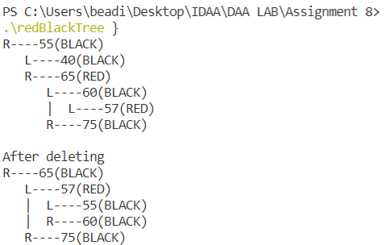

**Lab – 10**

|  |  |  |  |
| --- | --- | --- | --- |
| **S No** | **Program Title** | **Date of Implementation** | **Remarks** |
| i. | Greedy Algorithms | April 21, 2022 |  |

1. Deadline based job scheduling

Input:

The deadlines and profits of the jobs

Output:

The count of jobs and the total profit

Time Complexity:

Time complexity is O(MxN) where M is the maximum value of deadline of a job

Code:

#include<bits/stdc++.h>

using namespace :: std;

// we assume that each job takes 1 unit time to complete

class Job{

    public:

        int dead, profit;

};

bool comp(Job a, Job b){

    return a.profit>b.profit;

}

vector<int> JobScheduling(Job arr[], int n)

{

    int md=0;

    for(int i=0; i<n; i++){

        md=max(md, arr[i].dead);

    }

    vector<int> avail(md+1, -1);

    sort(arr, arr+n, comp);

    int pro=0, count=0;

    for(int i=0; i<n; i++){

        int j=arr[i].dead;

        while(j>0 && avail[j]!=-1){

            j--;

        }

        if(j>0 && avail[j]==-1){

            avail[j]=i;

            pro+=arr[i].profit;

            count++;

        }

    }

    return {count, pro};

}

int main(){

    int n = 0;

    cout<<"Enter the number of jobs: ";

    cin>>n;

    Job* arr = new Job[n];

    for(int i=0; i<n; i++){

        cout<<"Enter the deadline and profit for job"<<i+1<<":";

        cin>>arr[i].dead>>arr[i].profit;

    }

    vector<int> ans = JobScheduling(arr, n);

    cout<<"count of jobs = "<<ans[0]<<"\nprofit = "<<ans[1];

    return 0;

}

**Output:**

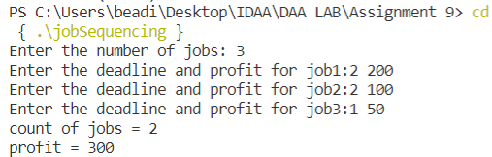

1. Activity Selection Problem

Input:

Time of start and end of each job

Output:

The number of jobs that can be completed

Time Complexity:

O(NlogN)

Code:

#include<bits/stdc++.h>

#define int long long int

#define ff first

#define ss second

#define pb push_back

#define pii pair<int, int>

using namespace :: std;

bool comp(pii a, pii b){

    return a.second<b.second;

}

int32_t main(){

    int n=0;

    cout<<"Enter the number of activities: ";

    cin>>n;

    vector<pii> v;

    for(int i=0; i<n; i++){

        pii p;

        cout<<"Enter the start time and end time of job"<<i+1<<":";

        cin>>p.first>>p.second;

        v.push_back(p);

    }

    sort(v.begin(), v.end(), comp);

    int ans=0;

    int end=0;

    int i=0;

    while(i<n){

        if(v[i].first<end){

            i++;

        }

        else{

            end = v[i].second;

            i++;

            ans++;

        }

    }

    cout<<"The number of jobs that can be done are: "<<ans<<"\n";

    return 0;

}

**Output:**

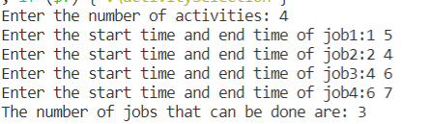

1. Huffman Code

Input:

-

Output:

Huffman code attached to each letter

Time Complexity:

O(NlogN)

Code:

#include<bits/stdc++.h>

#define MAX_TREE_HT 100

// A Huffman tree node

struct MinHeapNode {

    // One of the input characters

    char data;

    // Frequency of the character

    unsigned freq;

    // Left and right child of this node

    struct MinHeapNode *left, *right;

};

// A Min Heap: Collection of

// min-heap (or Huffman tree) nodes

struct MinHeap {

    // Current size of min heap

    unsigned size;

    // capacity of min heap

    unsigned capacity;

    // Array of minheap node pointers

    struct MinHeapNode** array;

};

// A utility function allocate a new

// min heap node with given character

// and frequency of the character

struct MinHeapNode* newNode(char data, unsigned freq){

    struct MinHeapNode* temp = (struct MinHeapNode*)malloc(

        sizeof(struct MinHeapNode));

    temp->left = temp->right = NULL;

    temp->data = data;

    temp->freq = freq;

    return temp;

}

// A utility function to create

// a min heap of given capacity

struct MinHeap* createMinHeap(unsigned capacity){

    struct MinHeap* minHeap

        = (struct MinHeap*)malloc(sizeof(struct MinHeap));

    // current size is 0

    minHeap->size = 0;

    minHeap->capacity = capacity;

    minHeap->array = (struct MinHeapNode**)malloc(

        minHeap->capacity * sizeof(struct MinHeapNode*));

    return minHeap;

}

// A utility function to

// swap two min heap nodes

void swapMinHeapNode(struct MinHeapNode** a, struct MinHeapNode** b)

{

    struct MinHeapNode* t = *a;

    *a = *b;

    *b = t;

}

// The standard minHeapify function.

void minHeapify(struct MinHeap* minHeap, int idx){

    int smallest = idx;

    int left = 2 * idx + 1;

    int right = 2 * idx + 2;

    if (left < minHeap->size

        && minHeap->array[left]->freq

            < minHeap->array[smallest]->freq)

        smallest = left;

    if (right < minHeap->size

        && minHeap->array[right]->freq

            < minHeap->array[smallest]->freq)

        smallest = right;

    if (smallest != idx) {

        swapMinHeapNode(&minHeap->array[smallest],

                        &minHeap->array[idx]);

        minHeapify(minHeap, smallest);

    }

}

// A utility function to check

// if size of heap is 1 or not

int isSizeOne(struct MinHeap* minHeap){

    return (minHeap->size == 1);

}

// A standard function to extract

// minimum value node from heap

struct MinHeapNode* extractMin(struct MinHeap* minHeap){

    struct MinHeapNode* temp = minHeap->array[0];

    minHeap->array[0] = minHeap->array[minHeap->size - 1];

    --minHeap->size;

    minHeapify(minHeap, 0);

    return temp;

}

// A utility function to insert

// a new node to Min Heap

void insertMinHeap(struct MinHeap* minHeap, struct MinHeapNode* minHeapNode){

    ++minHeap->size;

    int i = minHeap->size - 1;

    while (i

        && minHeapNode->freq

                < minHeap->array[(i - 1) / 2]->freq) {

        minHeap->array[i] = minHeap->array[(i - 1) / 2];

        i = (i - 1) / 2;

    }

    minHeap->array[i] = minHeapNode;

}

// A standard function to build min heap

void buildMinHeap(struct MinHeap* minHeap){

    int n = minHeap->size - 1;

    int i;

    for (i = (n - 1) / 2; i >= 0; --i)

        minHeapify(minHeap, i);

}

// A utility function to print an array of size n

void printArr(int arr[], int n){

    int i;

    for (i = 0; i < n; ++i)

        printf("%d", arr[i]);

    printf("\n");

}

// Utility function to check if this node is leaf

int isLeaf(struct MinHeapNode* root){

    return !(root->left) && !(root->right);

}

// Creates a min heap of capacity

// equal to size and inserts all character of

// data[] in min heap. Initially size of

// min heap is equal to capacity

struct MinHeap* createAndBuildMinHeap(char data[], int freq[], int size){

    struct MinHeap* minHeap = createMinHeap(size);

    for (int i = 0; i < size; ++i)

        minHeap->array[i] = newNode(data[i], freq[i]);

    minHeap->size = size;

    buildMinHeap(minHeap);

    return minHeap;

}

// The main function that builds Huffman tree

struct MinHeapNode* buildHuffmanTree(char data[], int freq[], int size){

    struct MinHeapNode *left, *right, *top;

    // Step 1: Create a min heap of capacity

    // equal to size. Initially, there are

    // modes equal to size.

    struct MinHeap* minHeap

        = createAndBuildMinHeap(data, freq, size);

    // Iterate while size of heap doesn't become 1

    while (!isSizeOne(minHeap)) {

        // Step 2: Extract the two minimum

        // freq items from min heap

        left = extractMin(minHeap);

        right = extractMin(minHeap);

        // Step 3: Create a new internal

        // node with frequency equal to the

        // sum of the two nodes frequencies.

        // Make the two extracted node as

        // left and right children of this new node.

        // Add this node to the min heap

        // '$' is a special value for internal nodes, not

        // used

        top = newNode('$', left->freq + right->freq);

        top->left = left;

        top->right = right;

        insertMinHeap(minHeap, top);

    }

    // Step 4: The remaining node is the

    // root node and the tree is complete.

    return extractMin(minHeap);

}

// Prints huffman codes from the root of Huffman Tree.

// It uses arr[] to store codes

void printCodes(struct MinHeapNode* root, int arr[], int top){

    // Assign 0 to left edge and recur

    if (root->left) {

        arr[top] = 0;

        printCodes(root->left, arr, top + 1);

    }

    // Assign 1 to right edge and recur

    if (root->right) {

        arr[top] = 1;

        printCodes(root->right, arr, top + 1);

    }

    // If this is a leaf node, then

    // it contains one of the input

    // characters, print the character

    // and its code from arr[]

    if (isLeaf(root)) {

        printf("%c: ", root->data);

        printArr(arr, top);

    }

}

// The main function that builds a

// Huffman Tree and print codes by traversing

// the built Huffman Tree

void HuffmanCodes(char data[], int freq[], int size){

    // Construct Huffman Tree

    struct MinHeapNode* root

        = buildHuffmanTree(data, freq, size);

    // Print Huffman codes using

    // the Huffman tree built above

    int arr[MAX_TREE_HT], top = 0;

    printCodes(root, arr, top);

}

int main(){

    char arr[] = { 'a', 'b', 'c', 'd', 'e', 'f' };

    int freq[] = { 5, 9, 12, 13, 16, 45 };

    int size = sizeof(arr) / sizeof(arr[0]);

    HuffmanCodes(arr, freq, size);

    return 0;

}

**Output:**

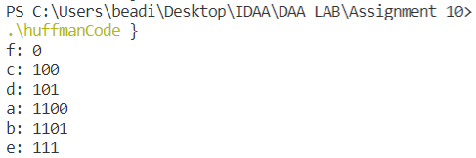

1. Kruskals Algorithm for MST

Input:

Edges of the graph and their weights

Output:

The weight of minimum spanning tree

Time Complexity:

O(ElogV) where E is number of edges and V is number of vertices

Code:

#include<bits/stdc++.h>

using namespace :: std;

bool comp(pair<pair<int, int>, int> a, pair<pair<int, int>, int> b){

    return a.second<b.second;

}

class Graph{

    public:

        int v;

        vector<pair<pair<int, int>, int> > l;

        Graph(int n){

            this->v=n;

        }

        void addEdge(int a, int b, int w){

            l.push_back({{a, b}, w});

        }

        int findSet(int i, int par[]){

            if(par[i]==-1) return i;

            return par[i] = findSet(par[i], par);

        }

        void unionSet(int i, int j, int par[], int rank[]){

            int p1 = findSet(i, par);

            int p2 = findSet(j, par);

            if(p1!=p2){

                if(rank[p1]>rank[p2]){

                    par[p2]=p1;

                    rank[p1]+=rank[p2];

                }

                else{

                    par[p1]=p2;

                    rank[p2]+=rank[p1];

                }

            }

        }

        int kruskalsMST(){

            sort(l.begin(), l.end(), comp);

            int par[v];

            int rank[v];

            for(int i=0; i<v; i++){

                par[i]=-1;

                rank[i]=1;

            }

            int ans=0;

            for(auto i:l){

                int a=i.first.first;

                int b=i.first.second;

                int w=i.second;

                if(findSet(a, par)!=findSet(b, par)){

                    unionSet(a, b, par, rank);

                    ans+=w;

                }

            }

            return ans;

        }

};

int main(){

    Graph g(4);

    g.addEdge(0, 1, 1);

    g.addEdge(0, 2, 2);

    g.addEdge(0, 3, 2);

    g.addEdge(1, 2, 2);

    g.addEdge(2, 3, 3);

    g.addEdge(1, 3, 3);

    cout<<"MST = "<<g.kruskalsMST();

    return 0;

}

**Output:**

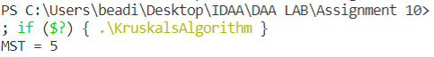

1. Prims Algorithm for MST

Input:

Edges of the graph and their weights

Output:

The weight of the minimum spanning tree

Time Complexity:

O((V + E)logV) where E is number of edges and V is number of vertices

Code:

#include<bits/stdc++.h>

using namespace :: std;

class Graph{

    public:

        int v;

        vector<pair<int, int> > * l;

        Graph(int n){

            this->v=n;

            l=new vector<pair<int, int> > [n];

        }

        void addEdge(int a, int b, int w){

            l[a].push_back({b, w});

            l[b].push_back({a, w});

        }

        int primsMST(){

            priority_queue<pair<int, int>, vector<pair<int, int> > , greater<pair<int, int> > > q;

            bool*vis= new bool [v]{false};

            int ans=0;

            q.push({0, 0});

            while(!q.empty()){

                int to=q.top().second;

                int w=q.top().first;

                q.pop();

                if(vis[to]){

                    continue;

                }

                ans+=w;

                vis[to]=true;

                for(auto i:l[to]){

                    if(!vis[i.first]){

                        q.push({i.second, i.first});

                    }

                }

            }

            return ans;

        }

};

int main(){

    Graph g(4);

    g.addEdge(0, 1, 1);

    g.addEdge(0, 2, 2);

    g.addEdge(0, 3, 2);

    g.addEdge(1, 2, 2);

    g.addEdge(2, 3, 3);

    g.addEdge(1, 3, 3);

    cout<<"MST = "<<g.primsMST();

    return 0;

}

**Output:**



1. Fractional Knapsack

Input:

Integer weights and values

Output:

Integer – Maximum value that can be accommodated

Time Complexity:

O(NlogN)

Code:

#include<bits/stdc++.h>

using namespace :: std;

class Item{

    public:

        int weight, value;

};

bool comp(Item a, Item b){

    return (1.0*a.value)/a.weight > (1.0*b.value)/b.weight;

}

double fractionalKnapsack(int W, Item arr[], int n)

{

    double ans=0;

    sort(arr, arr+n, comp);

    int id=0;

    while(W && id<n){

        if(W>=arr[id].weight){

            W-=arr[id].weight;

            ans+=arr[id].value;

        }

        else{

            ans+=((1.0*arr[id].value)/(1.0*arr[id].weight))*W;

            W=0;

        }

        id++;

    }

    return ans;

}

int main(){

    int n = 0, W = 0;

    cout<<"Enter the number of items: ";

    cin>>n;

    cout<<"Enter the size of knapsack: ";

    cin>>W;

    Item *arr = new Item[n];

    for(int i=0; i<n; i++){

        cout<<"Enter the weight and value for item "<<i+1<<":";

        cin>>arr[i].weight>>arr[i].value;

    }

    cout<<"The maximum value that can be accomodated = "<<fractionalKnapsack(W, arr, n);

    return 0;

}

**Output:**

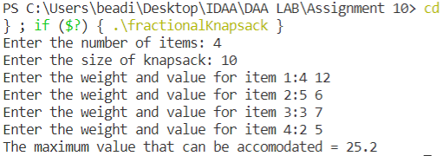

1. Dijkstras Algortihm for Single Source Shortest Path

Input:

Edges of the graph and their weights

Output:

Array containing the shortest paths of each node from the source node

Time Complexity:

O(V+Elog(V)), where E is number of edges and V is number of vertices

Code:

#include<bits/stdc++.h>

using namespace std;

vector<int> shortestPath(vector<vector<int> > roads,int n)

{

    vector<pair<int, int> > l[n+1];

    for(auto i:roads){

        l[i[0]].push_back({i[1], i[2]});

        l[i[1]].push_back({i[0], i[2]});

    }

    vector<int> dist(n+1, INT_MAX);

    vector<int> par(n+1, -1);

    set<pair<int, int> > s;

    dist[1]=0;

    s.insert({0, 1});

    while(!s.empty()){

        auto it=s.begin();

        s.erase(it);

        int node = it->second;

        int nodeDist = it->first;

        for(auto i:l[node]){

            int nbr=i.first;

            int wt = i.second;

            if(dist[nbr]>(nodeDist+wt)){

                par[nbr]=node;

                auto f=s.find({dist[nbr], nbr});

                if(f!=s.end()){

                    s.erase(f);

                }

                dist[nbr]=nodeDist+wt;

                s.insert({dist[nbr], nbr});

            }

        }

    }

    // for(auto i:par){

    //     cout<<i<<" ";

    // }

    // cout<<"\n";

    stack<int> u;

    int d=n;

    while(par[d]!=-1){

        u.push(d);

        d=par[d];

    }

    u.push(1);

    vector<int> ans;

    while(!u.empty()){

        ans.push_back(u.top());

        u.pop();

    }

    return ans;

}

int main(){

    int n=5;

    vector<vector<int> > edges = {{1,2,2},{2,5,5},{2,3,4},{1,4,1},{4,3,3},{3,5,1}};

    vector<int> ans=shortestPath(edges, n);

    for(auto i:ans){

        cout<<i<<" ";

    }

    return 0;

}

**Output:**

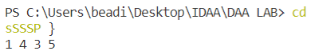

1. Bellman Ford Algortihm for Single Source Shortest Path

Input:

Edges of the graph and their weights

Output:

Array containing the shortest paths of each node from the source node

Time Complexity:

O(V*E), where E is number of edges and V is number of vertices

Code:

#include<bits/stdc++.h>

using namespace :: std;

// SSSP for graphs with negative edges

vector<int> bellmanFord(int n, vector<vector<int> > edges, int src){

    vector<int> dist(n+1, INT_MAX);

    dist[src]=0;

    for(int i=0; i<n-1; i++){

        for(auto i: edges){

            int u=i[0];

            int v=i[1];

            int wt=i[2];

            if(dist[u]!=INT_MAX && dist[v]>(dist[u]+wt)){

                dist[v]=dist[u]+wt;

            }

        }

    }

    // negative edge cycle detection

    for(auto i:edges){

        int u=i[0];

        int v=i[1];

        int wt=i[2];

        if(dist[u]!=INT_MAX && dist[v]>(dist[u]+wt)){

            cout<<"Negative Edge Cycle Present";

            exit(0);

        }

    }

    return dist;

}

int main(){

    int n=0, m=0;

    cin>>n>>m;

    vector<vector<int> > edges;

    for(int i=0; i<m; i++){

        int u=0, v=0, wt=0;

        cin>>u>>v>>wt;

        edges.push_back({u, v, wt});

    }

    vector<int> dist = bellmanFord(n, edges, 1);

    for(int i=1; i<n+1; i++){

        cout<<"node "<<i<<" is at a distance: "<<dist[i]<<"\n";

    }

    return 0;

}

**Output:**

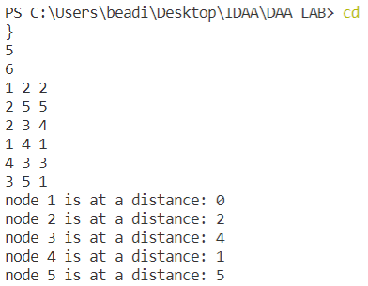

**Lab – 11**

|  |  |  |  |
| --- | --- | --- | --- |
| **S No** | **Program Title** | **Date of Implementation** | **Remarks** |
| i. | Dynamic Programming Algorithms | April 28, 2022 |  |

1. 0/1 Knapsack Problem

Input:

Integer weights and values

Output:

Integer – Maximum value that can be accommodated

Time Complexity:

O(n*m) , n = no. of items

m = size of knapsack

**Code:**

#include<bits/stdc++.h>

using namespace :: std;

int knapsack(int wt[], int val[], int n, int W){

    int t[102][1002];

    for(int i=0; i<n+1; i++){

        for(int j=0; j<W+1; j++){

            if(i==0 || j==0){

                t[i][j]=0;

            }

        }

    }

    for(int i=1; i<n+1; i++){

        for(int j=1; j<W+1; j++){

            if(wt[i-1]<=j){

                t[i][j]= max(val[i-1]+t[i-1][j-wt[i-1]], t[i-1][j]);

            }

            else{

                t[i][j]= t[i-1][j];

            }

        }

    }

    return t[n][W];

}

int main(){

    int n=0;

    cin>>n;

    int*wt=new int [n];

    int*val=new int [n];

    for(int i=0; i<n; i++){

        cin>>wt[i]>>val[i];

    }

    int W=0;

    cin>>W;

    cout<<knapsack(wt, val, n, W);

    return 0;

}

**Output:**

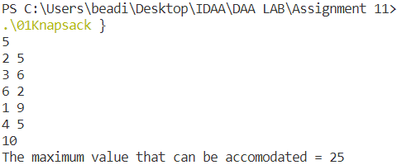

1. Assembly Line Scheduling

Input:

Time taken at each station for each assembly line along with time for switching

Output:

Minimum time taken to assemble the object

Time Complexity:

O(2*n) , n = no. of stations

**Code:**

#include<bits/stdc++.h>

using namespace :: std;

int t[2][10000];

int solveTab(int**A, int**P, int e[], int s[], int n){

    int t[2][n];

    for(int i=0; i<2; i++){

        t[i][0] = s[i]+A[i][0];

    }

    for(int j=1; j<n; j++){

        for(int i=0; i<2; i++){

            t[i][j] = A[i][j]+min(t[i][j-1], P[!i][j]+t[!i][j-1]);

        }

    }

    return min(e[0]+t[0][n-1], e[1]+t[1][n-1]);

}

int solve(int**A, int**P, int e[], bool path, int i, int n){

    if(i==n-1){

        return e[path]+A[path][i];

    }

    if(t[path][i]!=-1){

        return t[path][i];

    }

    return t[path][i] = A[path][i]+min(solve(A, P, e, path, i+1, n), solve(A, P, e, !path, i+1, n)+ P[path][i+1]);

}

int main(){

    memset(t, -1, sizeof(t));

    int n=0;

    cin>>n;

    int**A=new int*[2];

    int**P=new int*[2];

    for(int i=0; i<2; i++){

        A[i]=new int [n];

        P[i]=new int [n];

    }

    int start[2];

    for(int i=0; i<2; i++){

        cin>>start[i];

    }

    for(int i=0; i<2; i++){

        for(int j=0; j<n; j++){

            cin>>A[i][j];

        }

    }

    for(int i=0; i<2; i++){

        for(int j=0; j<n; j++){

            cin>>P[i][j];

        }

    }

    int end[2];

    for(int i=0; i<2; i++){

        cin>>end[i];

    }

    // cout<<min(start[0]+solve(A, P, end, false, 0, n), start[1]+solve(A, P, end, true, 0, n))<<"\n";

    cout<<"The time taken = "<<solveTab(A, P, end, start, n)<<"\n";

    return 0;

}

**Output:**

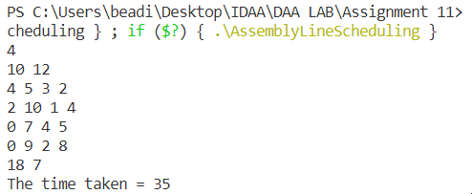

1. Longest Common Subsequence

Input:

Two strings

Output:

Length of LCS of the given two strings

Time Complexity:

O(n*m) , n and m are lengths of strings

**Code:**

#include<bits/stdc++.h>

using namespace :: std;

int t[102][1002];

int LCS(string x, string y, int n, int m){

    if(n==0 || m==0){

        return t[n][m]=0;

    }

    if(t[n][m]!=-1){

        return t[n][m];

    }

    else{

        if(x[n-1]==y[m-1]){

            return t[n][m]=(1+LCS(x, y, n-1, m-1));

        }

        else{

            return t[n][m]=max(LCS(x, y, n-1, m),LCS(x, y, n, m-1));

        }

    }

}

int main(){

    for(int i=0; i<102; i++){

        for(int j=0; j<1002; j++){

            t[i][j]=-1;

        }

    }

    string x, y;

    cin>>x>>y;

    int n=x.length();

    int m=y.length();

    cout<<"Length of LCS = "<<LCS(x, y, n, m)<<endl;

    return 0;

}

**Output:**

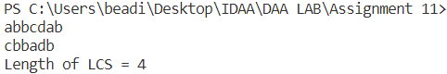

1. Matrix Chain Multiplication

Input:

Array representing n-1 matrices

Output:

Minimum number of calculations to get the product matrix

Time Complexity:

O(n^3) , n is the size of array

**Code:**

#include<bits/stdc++.h>

using namespace :: std;

int t[1002][1002];

int MCMmemoized(int A[], int i, int j){

    if(t[i][j]!=-1){

        return t[i][j];

    }

    else{

        int temp=INT_MAX;

        for(int k=i; k<j; k++){

            t[i][k]=MCMmemoized(A, i, k);

            t[k+1][j]=MCMmemoized(A, k+1, j);

            int tempAns=t[i][k]+t[k+1][j]+(A[i-1]*A[k]*A[j]);

            if(tempAns<temp){

                temp=tempAns;

            }

        }

        return t[i][j]=temp;

    }

}

int main(){

    int n=0;

    cin>>n;

    for(int i=0; i<n+1; i++){

        for(int j=0; j<n+1; j++){

            t[i][j]=-1;

            if(i>=j){

                t[i][j]=0;

            }

        }

    }

    int*A=new int [n];

    for(int i=0; i<n; i++){

        cin>>A[i];

    }

    cout<<”Minimum number of calculations required = ”<<MCMmemoized(A, 1, n-1);

    return 0;

}

**Output:**

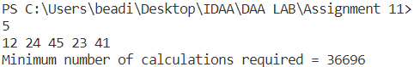

1. Bellman Ford

Input:

Edge list of the graph

Output:

Distance of each node from the source node (1)

Time Complexity:

O(n*m) , n = number of nodes in graph

M = number of edges in the graph

**Code:**

#include<bits/stdc++.h>

using namespace :: std;

vector<int> bellmanFord(int n, vector<vector<int> > edges, int src){

    vector<int> dist(n+1, INT_MAX);

    dist[src]=0;

    for(int i=0; i<n-1; i++){

        for(auto i: edges){

            int u=i[0];

            int v=i[1];

            int wt=i[2];

            if(dist[u]!=INT_MAX && dist[v]>(dist[u]+wt)){

                dist[v]=dist[u]+wt;

            }

        }

    }

    // negative edge cycle detection

    for(auto i:edges){

        int u=i[0];

        int v=i[1];

        int wt=i[2];

        if(dist[u]!=INT_MAX && dist[v]>(dist[u]+wt)){

            cout<<"Negative Edge Cycle Present";

            exit(0);

        }

    }

    return dist;

}

int main(){

    int n=0, m=0;

    cin>>n>>m;

    vector<vector<int> > edges;

    for(int i=0; i<m; i++){

        int u=0, v=0, wt=0;

        cin>>u>>v>>wt;

        edges.push_back({u, v, wt});

    }

    vector<int> dist = bellmanFord(n, edges, 1);

    for(int i=1; i<n+1; i++){

        cout<<"node "<<i<<" is at a distance: "<<dist[i]<<"\n";

    }

    return 0;

}

**Output:**

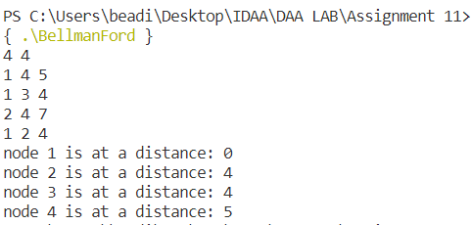

1. Floyd Warshall

Input:

Adjacency Matrix of the graph

Output:

Distance between each pair of nodes (represented as a distance matrix)

Time Complexity:

O(n^3) , n = number of nodes in graph

**Code:**

#include<bits/stdc++.h>

using namespace :: std;

vector<vector<int> > floyd_warshall(vector<vector<int> > graph){

    vector<vector<int> > dist(graph);

    int v=graph.size();

    for(int k=0; k<v; k++){

        for(int i=0; i<v; i++){

            for(int j=0; j<v; j++){

                if(dist[i][k]!=INT_MAX && dist[k][j]!=INT_MAX && dist[i][j]>(dist[i][k]+dist[k][j])){

                    dist[i][j]=dist[i][k]+dist[k][j];

                }

            }

        }

    }

    return dist;

}

int main(){

    vector<vector<int> > graph={{0, INT_MAX, -2, INT_MAX},{4, 0, 3, INT_MAX},{INT_MAX, INT_MAX, 0, 2},{INT_MAX, -1, INT_MAX, 0}};

    vector<vector<int> > ans = floyd_warshall(graph);

cout<<"Shortest Distance Matrix for the given graph: \n";

    for(auto i: ans){

        for(int j=0; j<graph.size(); j++){

            cout<<i[j]<<" ";

        }

        cout<<"\n";

    }

    return 0;

}

**Output:**

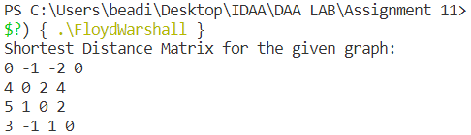

1. Optimal Binary Search Tree

Input:

Key and Frequency array

Output:

The minimum cost of the searches in the optimal BST

Time Complexity:

O(n^4) , n = number of nodes

**Code:**

#include <bits/stdc++.h>

using namespace std;

int sum(int freq[], int i, int j);

int optCost(int freq[], int i, int j){

    if (j < i)

        return 0;

    if (j == i)

        return freq[i];

    int fsum = sum(freq, i, j);

    int min = INT_MAX;

    for (int r = i; r <= j; ++r){

        int cost = optCost(freq, i, r - 1) + optCost(freq, r + 1, j);

        if (cost < min)

            min = cost;

    }

    return min + fsum;

}

int optimalSearchTree(int keys[], int freq[], int n){

    return optCost(freq, 0, n - 1);

}

int sum(int freq[], int i, int j)

{

    int s = 0;

    for (int k = i; k <= j; k++)

    s += freq[k];

    return s;

}

int main()

{

    int keys[] = {10, 12, 20};

    int freq[] = {34, 8, 50};

    int n = sizeof(keys) / sizeof(keys[0]);

    cout << "Cost of Optimal BST is "<< optimalSearchTree(keys, freq, n);

    return 0;

}

**Output:**



**------------------------------------- THANK YOU----------------------------------------------------------------------------------------------------------------------------------**